**SPH3U 5.1 Work**

1. **Work done by a constant force**

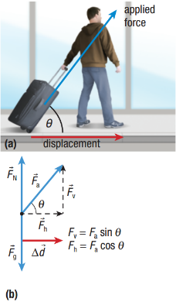

|  |  |
| --- | --- |
| Mechanical work: |  |
| equation |  |
| theta |  |
| special case |  |

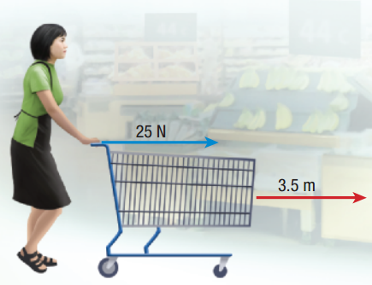How much mechanical work does a person do on a shopping cart if they apply a force of 25 N in the forward direction, and displace the cart 3.5 m in the same direction?

A curler applies a force of 15.0 N on a curling stone and accelerates the stone from rest to a speed of 8.00 m/s in 3.50 s. Assuming that the ice surface is level and frictionless, how much mechanical work does the curler do on the stone?

1. **Work done when force and displacement are in different directions**

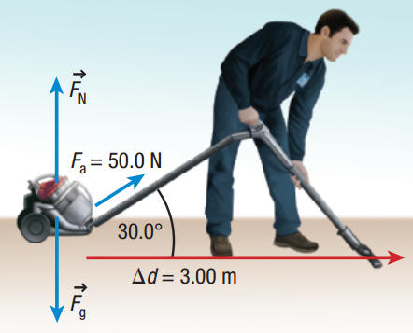  
Calculate the mechanical work done by a custodian on a vacuum cleaner if the custodian exerts an applied force of 50.0 N on the vacuum hose and the hose makes a 30.0° angle with the floor. The vacuum cleaner moves 3.00 m to the right on a level, flat surface.

1. **Special cases**

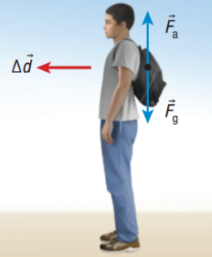  
Ranbir wears his backpack as he walks forward in a straight hallway. He walks at a constant velocity of 0.8 m/s for a distance of 12 m. How much mechanical work does Ranbir do on his backpack?

How much mechanical work is done on a stationary car if a student pushing with a 300 N force fails to displace the car?

A shopper pushes a shopping cart on a horizontal surface with a horizontal applied force of 41.0 N for 11.0 m. The cart experiences a force of friction of 35.0 N. Calculate the total mechanical work done on the shopping cart.

1. **Graphing work done**

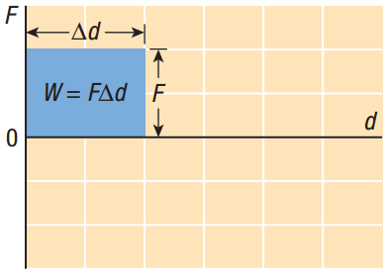 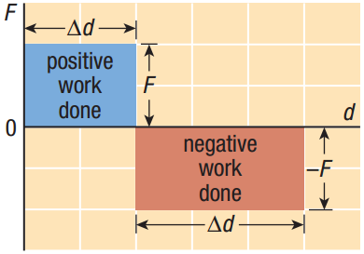 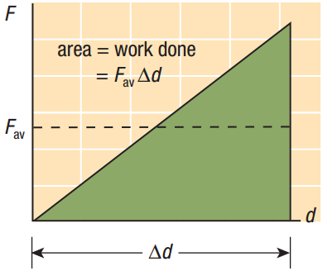

**Homework:** page 229: #1-3, 5-6, 9